Study Guide
Right Triangle – A triangle that has one right angle. 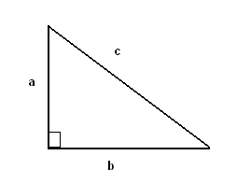

Equilateral Triangle – A triangle with all sides equal. 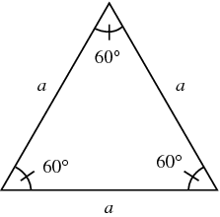

Isosceles Triangle – A triangle with at least two equal sides. 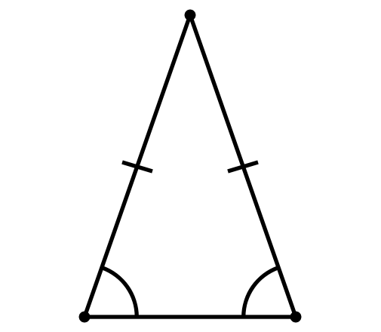

Scalene Triangle - A triangle with no congruent sides. 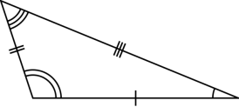

Remember all the angles in a triangle add up to 180 degrees.

Acute Angle - An angle that is less than 90 degrees. 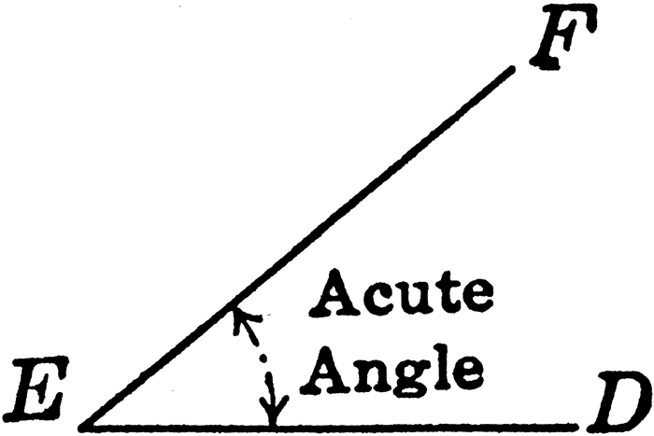

Rhombus - 4 equal sides with two equal angles.
Parallelogram - 2 opposite sides that are parallel, and 2 pairs of opposite sides that are equal.
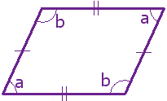
Trapezoid – Exactly 1 pair of parallel sides.

Regular Polygon - A closed figure made up of sides that do not cross. All sides are equal lengths and all angles are equal measures. 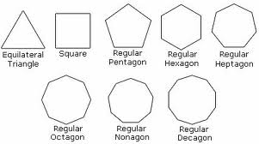

Obtuse Angle – An angle which is more than 90 degrees but less than 180 degrees. 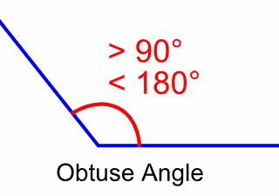

Non-Regular Polygon – Not all sides or angles are equal. 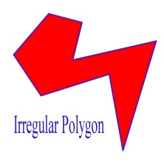

Perpendicular Lines – Lines that cross to form a right angle. 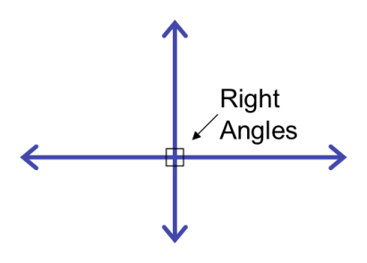

Congruent Lines – Lines that are the same length. 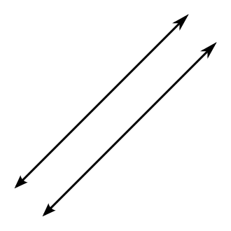

Straight line = A straight lines angle degree is 180.

Area: Length X Width

Perimeter: Add up all of sides lengths.

Right Angle – An angle that equals 90 degrees. 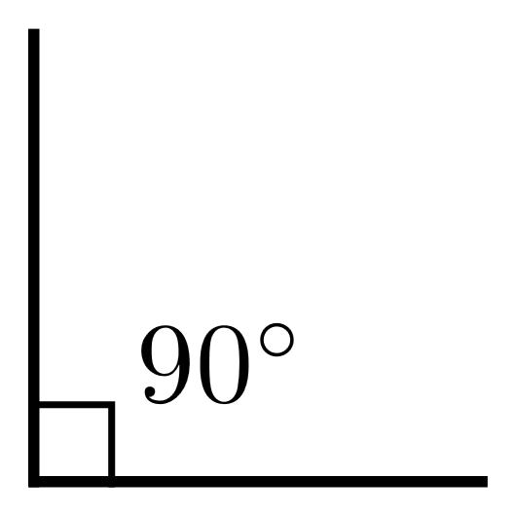

Quadrilateral – A four sided figure with four angles. 